**jewelry workshop**

Submitted by: MARYAM ALRUBYAYE



JEWELRY WORKSHOP

{Jewelry management system}

Submitted by:

MARYAM ALRUBAYE

Student number:

B1905.090004

In partial fulfillment for the award of the degree of

Programming 2 second term

In

SOFTWARE ENGINEERING

SCHOOL OF ENGINEERING

ISTANBUL AYDIN UNIVERSITY

Head of Department & Project Guide

Assoc.prof.(Ph.D.) TANER ÇEVİK

May 2020

Thank You

To Assoc.prof. (Ph.D.) TANER ÇEVİK

A teacher is a guide and a compass. You’ve shown me the path to success and walked with me along the way. Your high expectations in the lectures have helped give me confidence in myself. Thanks so much for all you’ve done.

TABLE OF CONTENTS:

Abstract ----------------------------------- (4)

Chapter 1

Introduction ------------------------------- (5)

1.1 Project aims and objectives ------------------- (5)

Chapter 2

System Analysis -------------------------- (6)

2.1 Software and hardware requirements -------- (6)

2.2 Programming tools used ----------------------- (7)

Chapter 3

Program explanation --------------------- (9)

3.1 login system ------------------------------------- (9)

3.2 The main page-----------------------------------(12)

3.3 Gold management system -------------------- (14)

3.4 Silver management system-------------------- (27)

3.5 Ingot analysis ----------------------------------- (39)

Chapter 4

Code analysis ----------------------------- (41)

Chapter 5

Conclusion---------------------------------(73)

References --------------------------------- (74)

ABSTRACT

Jewelry management system is a project which aims in provide all the needs of the jewelry workshop in terms of financial accounts and converts the values of both gold and silver into dollars and creating invoices.

This program will be abbreviated for the user to use the papers and pens to perform the infinite calculation also calculating the gram differences for both gold and silver before and after formulation and manufacture.

This program aims to make the working in the jewelry workshop more enjoyable with less effort, as well as decreasing the error percentage by 99%.

CHAPTER 1

INTRODUCTION

This chapter gives an overview about the aim, and objectives.

* 1. PROJECT AIMS AND OBJECTIVES
* It has two systems one is for gold management and the other is for silver management.
* Has ingot analysis and extraction of metal values.
* Contain subtraction table which saves all the out-quantity and the in-quantity differences that happened as a result of manufacturing process.
* Changes from grams to dollars for both gold and silver systems.
* In gold system the user can chose between all the calibers and know the specific price for each one.
* Contains all the manufacturing wages for both gold and silver systems.
* Contains invoice creating for both Silver and Gold System, this program save the invoice as a pdf file .
* The user can choose between saving the information and keep it for any period of time he wants or just start from the beginning.
* The user can calculate the total difference in both systems.

CHAPTER 2

SYSTEM ANALYSIS

2.1 Software and hardware requirements

This section describes the software and hardware requirements of the system to run the program in the most efficint way.

* SOFTWARE REQUIREMENTS

• Operating system- Windows 10 is used as the operating system as it is stable and supports more features and is more user friendly

• Development tools and Programming language- java with JDK 11.02 and javafx 11 is used to write the whole code.  
   
 - HARDWARE REQUIREMENTS

* Intel core i7 7th generation is used as a processor because it is reliable, stable and faster than other processors and we can run our pc for longtime.  By using this processor we can keep on developing our project without any worries.
* Ram 8 gb is used as it will provide super fast reading and writing capabilities and it will serve gratly in processing.

2.2 Programming tools used:

I used both Java with JDK11.02 and JavaFX11 to write the whole code,

Java was developed by a team led by James Gosling at Sun Microsystems. Sun Microsystems was purchased by Oracle in 2010. Originally called Oak, Java was designed in 1991 for use in embedded chips in consumer electronic appliances.

In 1995, renamed Java, it was redesigned for developing web applications. For the history of Java, see www.java.com/en/javahistory/index.jsp. Java has become enormously popular. Its rapid rise and wide acceptance can be traced to its design characteristics, particularly its promise that you can write a program once and run it anywhere. As stated by its designer, Java is simple, object oriented, distributed,

interpreted, robust, secure, architecture neutral, portable, high performance, multithreaded, and dynamic. For the anatomy of Java characteristics, see liveexample.pearsoncmg.com/etc/ JavaCharacteristics.pdf. Java is a full-featured, general-purpose programming language that can be used to develop robust mission-critical applications. Today, it is employed not only for web programming but also for developing stand-alone applications across platforms on servers, desktop computers, and mobile devices. It was used to develop the code to communicate with and control the robotic rover on Mars. Many companies that once considered Java to be more hype than substance are now using it to create distributed applications accessed by customers and partners across the Internet. For every new project being developed today, companies are asking how they can use Java to make their work easier. The World Wide Web is an electronic information repository that can be accessed on the Internet from anywhere in the world. The Internet, the Web’s infrastructure, has been around for more than 40 years. The colorful World Wide Web and sophisticated web browsers are the major reason for the Internet’s popularity. Java initially became attractive because Java programs can run from a web browser. Such programs are called applets. Today applets are no longer allowed to run from a Web browser in the latest version of Java due to security issues. Java, however, is now very popular for developing applications on web servers. These applications process data, perform computations, and generate dynamic webpages. Many commercial Websites are developed using Java on the backend. Java is a versatile programming language: You can use it to develop applications for desktop computers, servers, and small handheld devices. The software for Android cell phones is developed using Java.

JavaFX is a new framework for developing Java GUI programs. The JavaFX API is an excellent example of how the object-oriented principles are applied. This chapter serves two purposes. First, it presents the basics of JavaFX programming. Second, it uses JavaFX to demonstrate object-oriented design and programming. Specifically, this chapter introduces the framework of JavaFX and discusses JavaFX GUI components and their relationships. You will learn how to develop simple GUI programs using layout panes, groups, buttons, labels, text fields, colors, fonts, images, image views, and shapes

CHAPTER 3

PROGRAM EXPLAINATION

3.1 login system:

* A screen shot of a computer

  Description automatically generated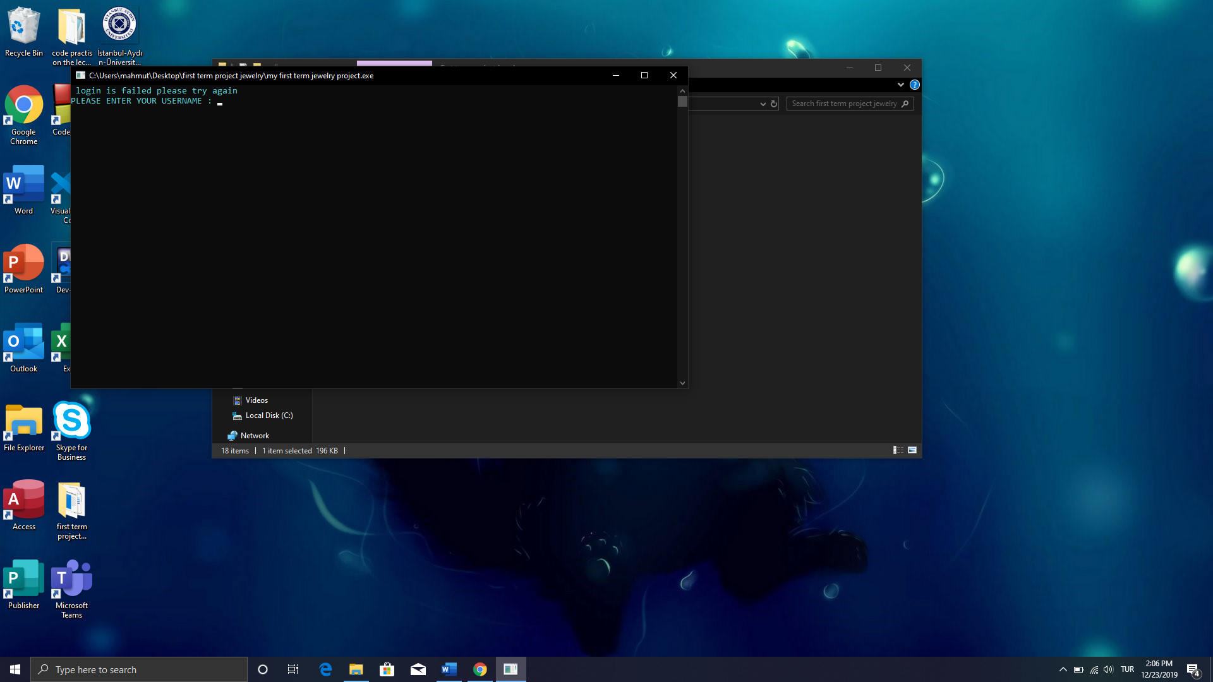This page shows up when the user enters wrong username or password.
* this is the page that shows up after login successflly.

3.2 The main page:

In the main page the user can chose between three options:

* The first option contains the gold management system.
* The second option contains the silver management system.
* The third option analysis the ingot and gives the extraction metals values.

3.3 Gold management system:

In the gold management system the user has 6 options to chose between them:

1. Everyday table

In everyday table the user will have to choose

* How many piece he wants to enter at that time.
* The user has to choose if he needs to start from the beginning and delete all the stored data from the file or proceed and add new data while keeping the current data in the file.
* The user will enter the out-quantity in grams and the in-quantity also in grams. After that the program will calculate the quantity differences by subtracting the two values and gives the result then calculate all the result for every single piece and gives their total result.
* Out-quantity -> this refers to the amount of gold in grams that’s came out from the box which contains all the gold in the company and keep it safe.
* In-quantity -> this refers to the amount of gold in grams that will be add back to the box after the manufacturing process, (there is always a weight loss after the manufacturing process is finished).
* The gold loss is measured by knowing the amount of gold particles lost throughout the process of gold pieces remodeling, this is done by collecting those particle from the device responsible for the remodeling and cleaning them from any residues by crimination process. Then the quantity of those particles is subtracted from the original value.
* The sum of the difference will be stored in a file that the user can retrieve to know the total loss from the total value in the box.

1. A screen shot of a computer monitor

   Description automatically generatedA close up of text on a white background

   Description automatically generated Calculate the total quantity difference:

Here the user could know the total loss from the total quantity for a specific period of time.

1. A close up of a piece of paper

   Description automatically generatedChange from grams to dollars

* Here the user can know the gram price for all gold caliber.
* In this program the gold caliber that is available

{24, 22, 21, 18, 14, 12, 8}

* To calculate the price of gold the program will do this calculation which is different from caliber to another ->
* In the 24 caliber the program will do this calculations : the program will take the ONS price for the day which will be taking from the user and divides it by 31.1 (has price ) then the program will multiply the result by both the grams amount and the wages which will be also taken from the user.
* In the 22 caliber the program will do the fallowing calculations : first it will take the ONS price for the day ,which will be taking from the user, and divides it by 31.1 (the HAS price ). Then the program will multiply the result by the grams amount and the result of this will be divided by 0.916. As a final step the result of the previous calculations will be multiplied by the wages to get the total price in dollars.

* In the 21 caliber the program will do the same exact caculations but instead of dividing by 0.916 it will be devide by 0.875.
* In the 18 caliber the program will do the same exact calculations but instead of dividing by 0.916 it will be devide by 0.750.
* In the 14 caliber the program will do the same exact calculations but instead of dividing by 0.916 it will be devide by 0.585.
* In the 12 caliber the program will do the same exact calculations but instead of dividing by 0.916 it will be divide by 0.500.
* In the 8 caliber the program will do the same exact calculations but instead of dividing by 0.916 it will be divide by 0.335.

1. GOLD MANUFACTURING WAGES

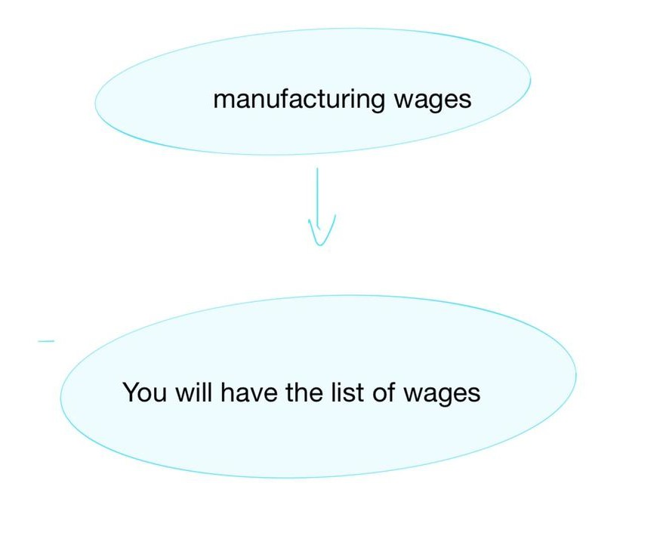

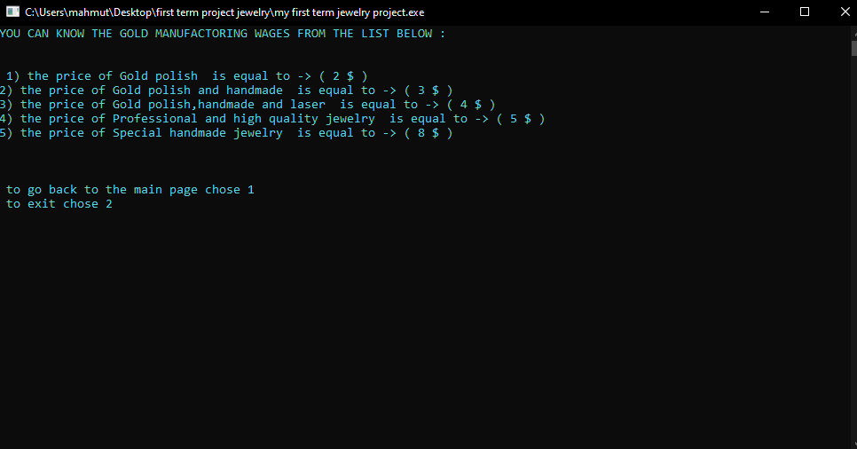

* When the user pic this choice. This list will show up which has the manufacturing wages to helps the user in knowing the pricing of the grams of each piece in dollars and the way it was manufactured.

The list for the gold manufacturing wages is:

1) The price of Gold polish is equal to -> (2 $)

2) The price of Gold polish and handmade is equal to -> (3 $) 3) the price of Gold polish, handmade and laser is equal to -> (4 $)

4) The price of Professional and high quality jewelry is equal to -> (5 $)

5) The price of Special handmade jewelry is equal to -> (8 $)

1. JEWELRY TYPES

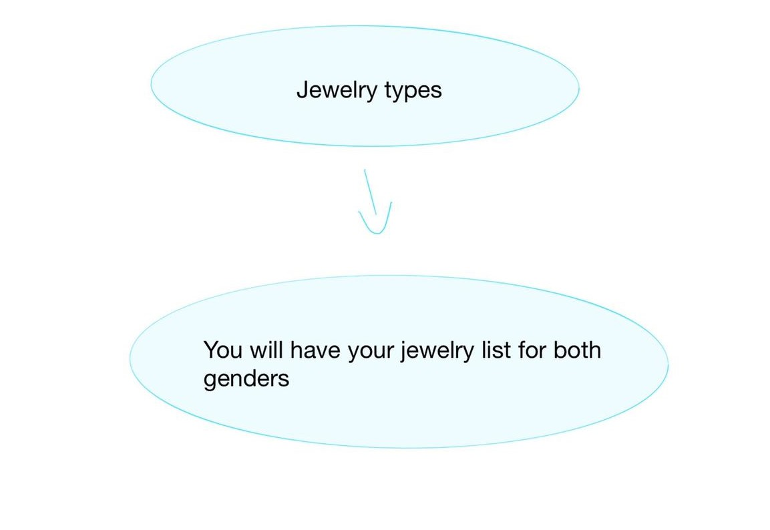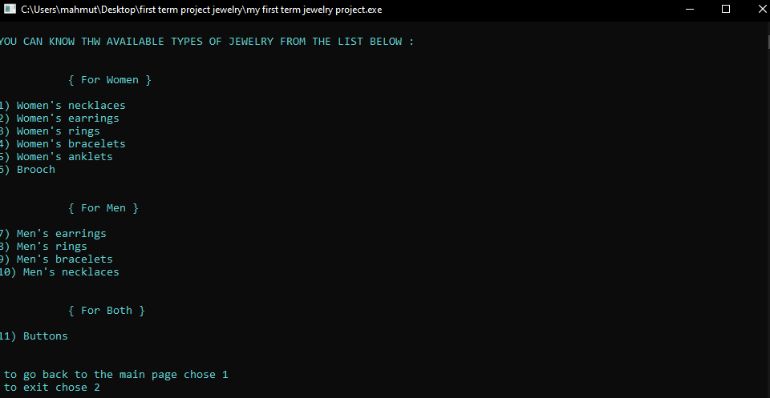

* When the user pic this choice. A list will show up showing all types of jewelry that the workshop provides.

The list of the available jewelry types is:

1) Women's necklaces

2) Women's earrings

3) Women's rings

4) Women's bracelets

5) Women's anklets

6) Brooch

7) Men's earrings

8) Men's rings

9) Men's bracelets

10) Men's necklaces

11) Buttons

1. GOING BACK TO THE MAIN PAGE AND EXITING

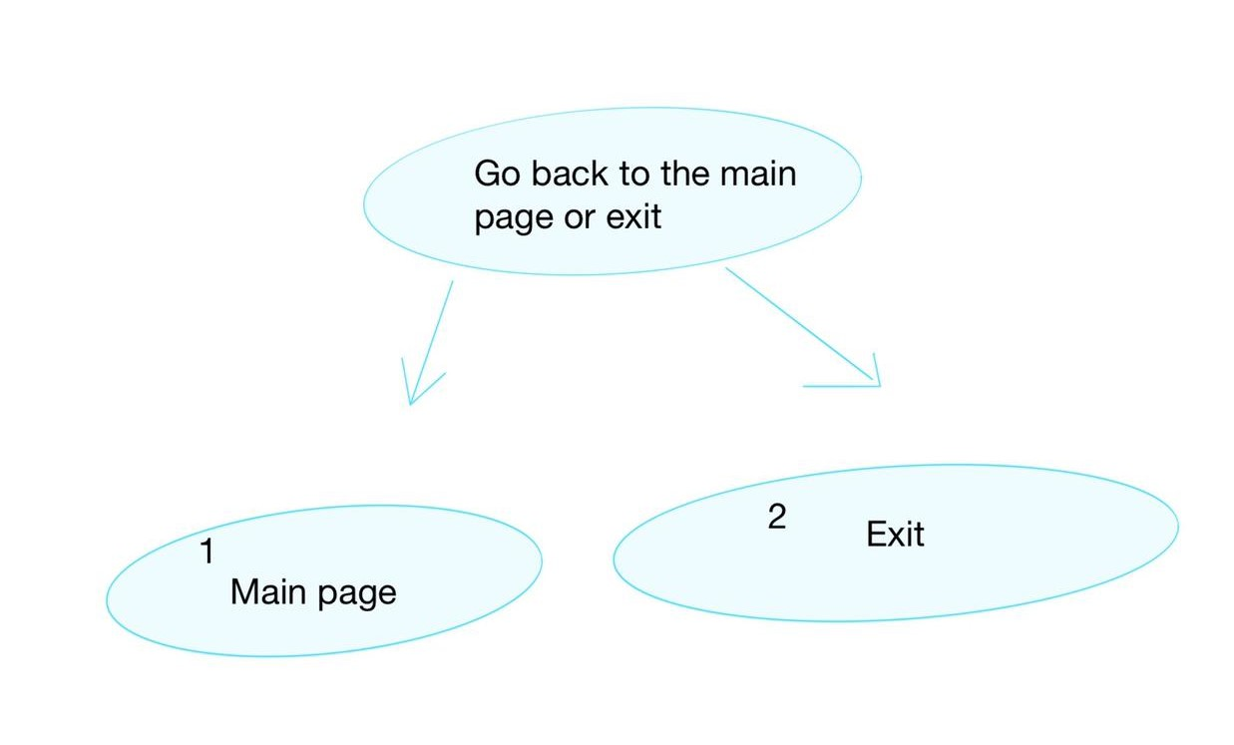

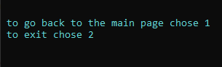

* This option is present in the first page of silver and gold systems. Also it will show up at the end of each function automatically. This option gives the user the ability to go back to the main page or exiting.

3.4 Silver management system

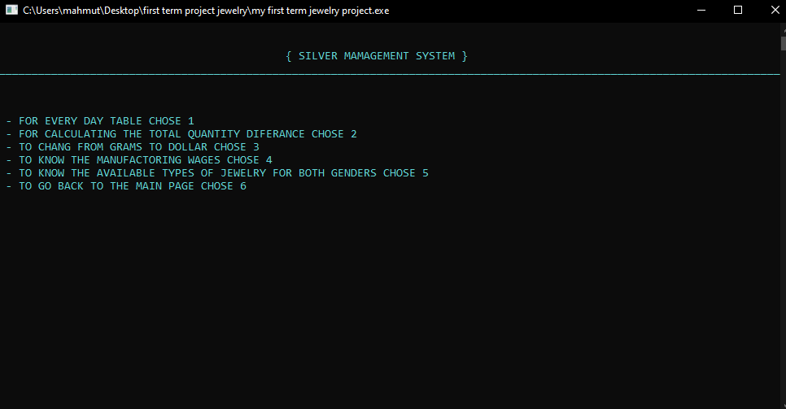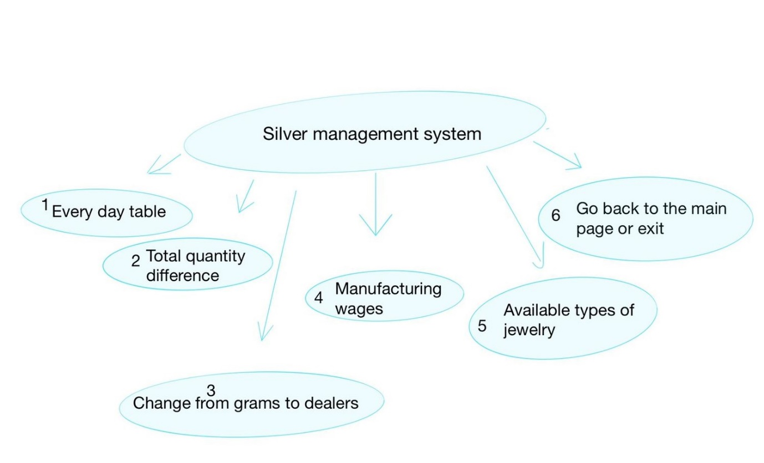

* In the silver management the user has six option to choose from:

1. FOR EVERYDAY TABLE CHOOSE

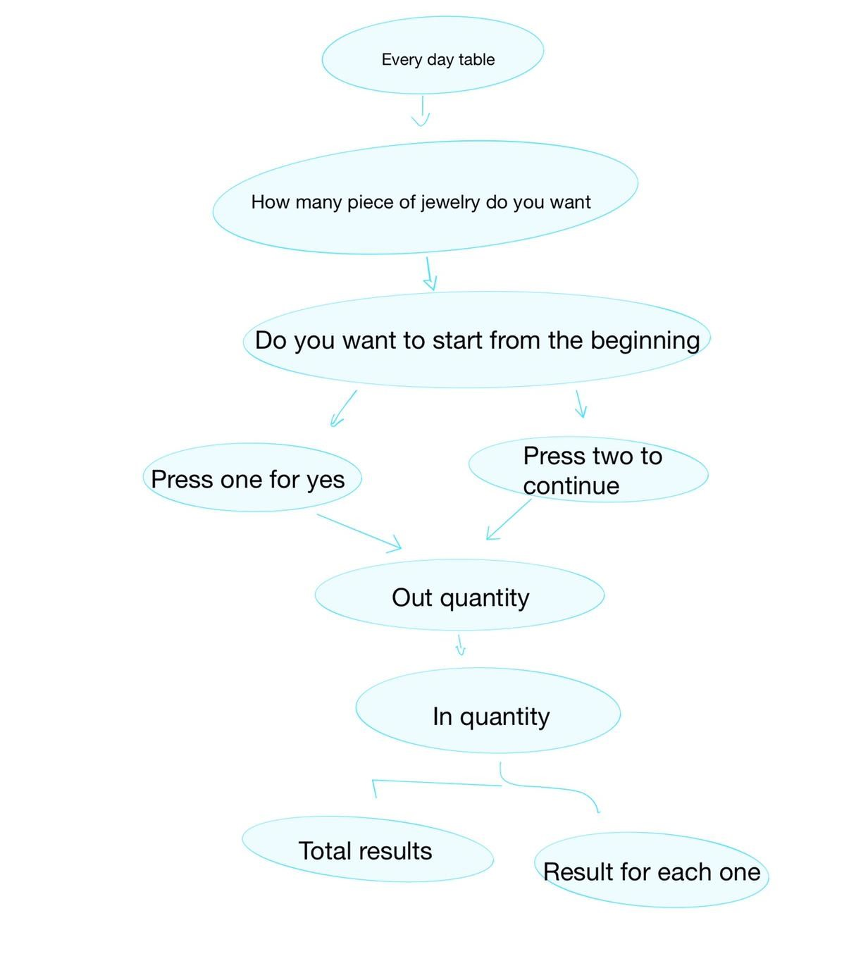

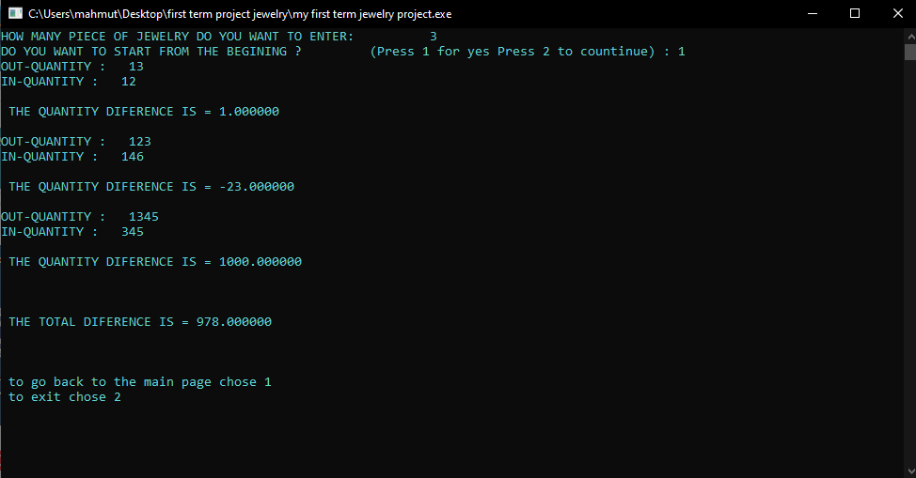

In everyday table the user will have to choose

* How many piece he wants to enter at that time.
* The user has to choose if he needs to start from the beginning and delete all the stored data from the file or proceed and add new data while keeping the current data in the file.
* The user will enter the out-quantity in grams and the in-quantity also in grams. After that the program will calculate the quantity differences by subtracting the two values and gives the result then calculate all the result for every single piece and gives their total result.
* Out-quantity -> this refers to the amount of gold in grams that’s came out from the box which contains all the gold in the company and keep it safe.
* In-quantity -> this refers to the amount of gold in grams that will be add back to the box after the manufacturing process, (there is always a weight loss after the manufacturing process is finished).
* The gold loss is measured by knowing the amount of gold particles lost throughout the process of gold pieces remodeling, this is done by collecting those particle from the device responsible for the remodeling and cleaning them from any residues by crimination process. Then the quantity of those particles is subtracted from the original value.
* The sum of the difference will be stored in a file that the user can retrieve to know the total loss from the total value in the box.

1. CALCULATING THE TOTAL QUANTITY DIFFERENCES

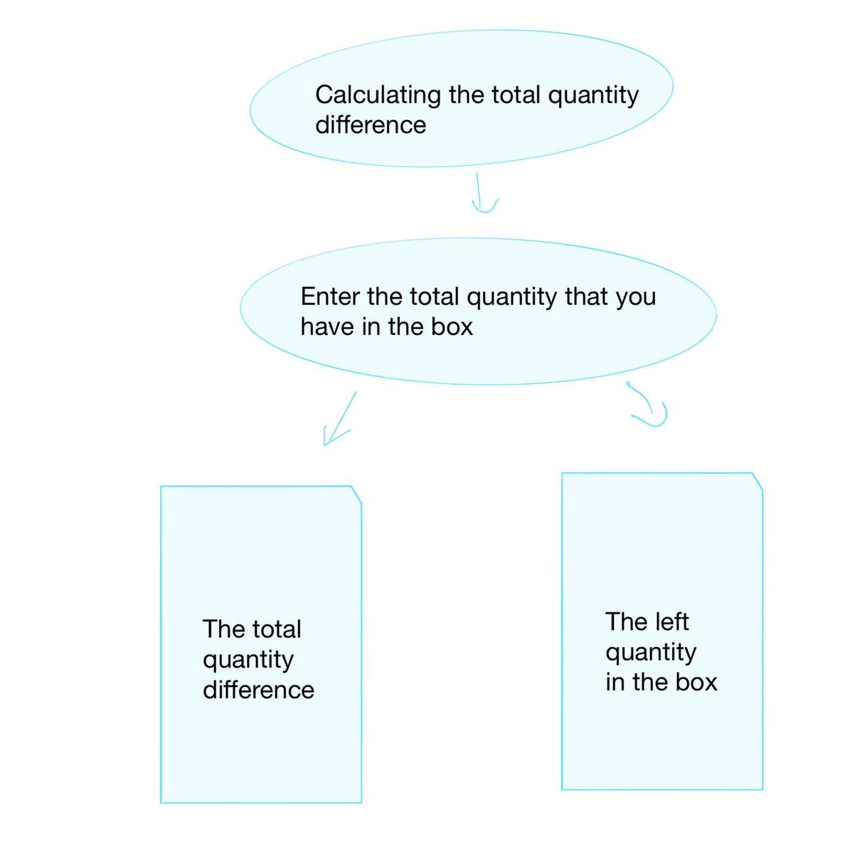

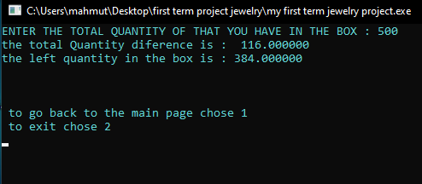

* Here the user can know the total loss from the total quantity for a specific period of time.

1. CHANGE FROM GRAM TO DOLLAR

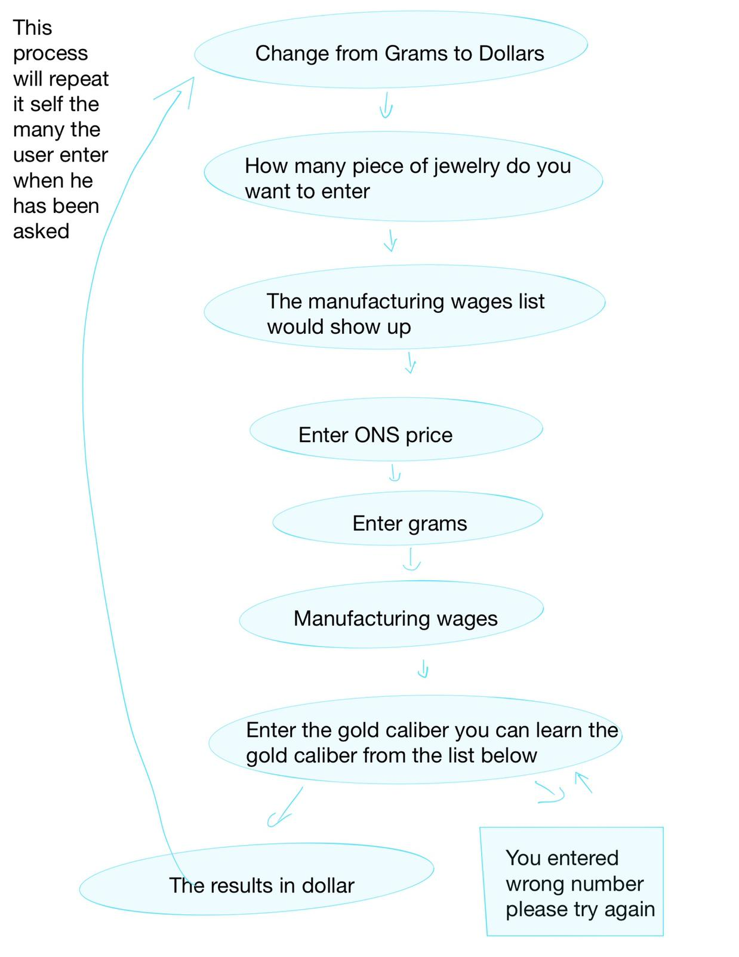

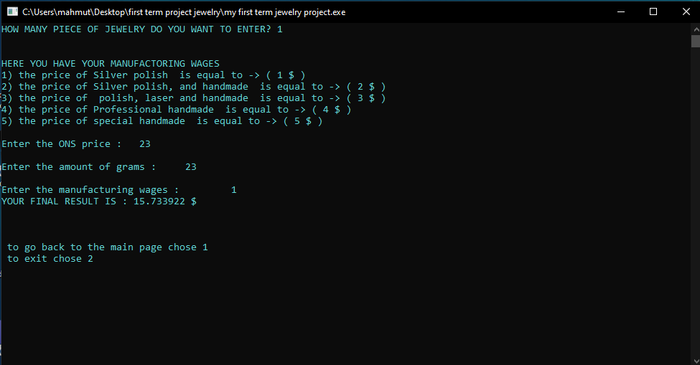

* To calculate the price of silver in dollars the program will do these calculations: first it will take the ONS price for the day, which will be entered by the user, and divides it by 31.1 (The HAS price). The result of this will be then multiplied by 0.925 and its’ result will be multiplied by the total grams the wages to get the price.

1. SILVER MANUFACTURING WAGES



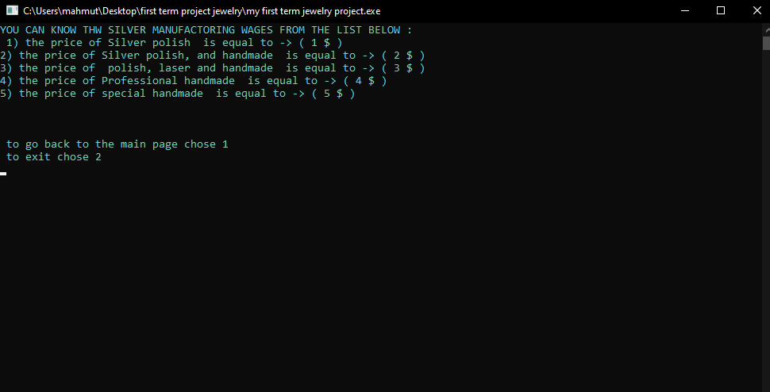

* When the user pic this choice. This list will show up which has the manufacturing wages to helps the user in knowing the pricing of the grams of each piece in dollars and the way it was manufactured.

The silver manufacturing wages:

1) The price of Silver polish is equal to -> (1 $)

2) The price of silver polish and handmade is equal to -> (2 $)

3) The price of polish, laser and handmade is equal to -> (3$)

4) The price of Professional handmade is equal to -> (4 $)

5) The price of special handmade is equal to -> (5 $)

1. JEWELRY TYPES





* When the user pic this choice. A list will show up showing all types of jewelry that the workshop provides.

The list of the available jewelry types is:

1) Women's necklaces

2) Women's earrings

3) Women's rings

4) Women's bracelets

5) Women's anklets

6) Brooch

7) Men's earrings

8) Men's rings

9) Men's bracelets

10) Men's necklaces

11) Buttons

1. GOING BACK TO THE MAIN PAGE AND EXITING





* This option is present in the first page of silver and gold systems. Also it will show up at the end of each function automatically. This option gives the user the ability to go back to the main page or exiting.

3.5 Ingot analysis and extraction of the metal value

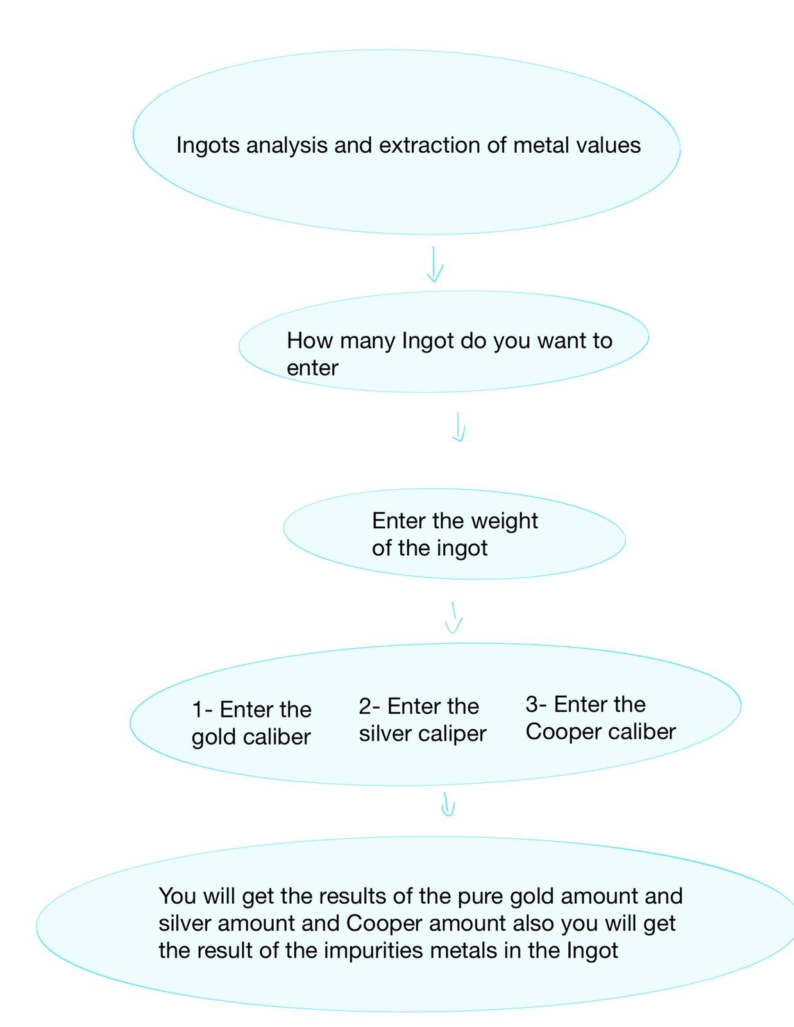

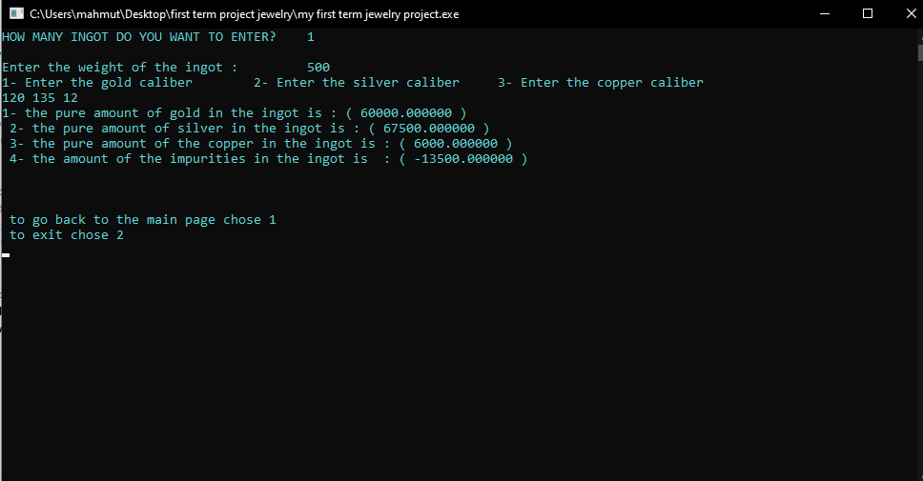

* In this option the ingot will be analyzed for figure out the amount of pure gold, silver and copper. Also to identify the impurities in the ingot.
* To analyse the ingot the program will do the fallowing calculations: it will multiply each of gold, silver and copper calibers by ingot weight.

CHAPTER 4

CODE ANALYSIS:

Standart libraries I used :

#include <stdio.h>

#include <stdlib.h>

#include <string.h>

#include <time.h>

libraries I create:

#include "mylibrary.h"

* İn this library I put two functions which is

1. void timetable(); // this function shows the specific date and time on the top of the screen.
2. void password(); // this function allowed the user to enter his user name and password in order to enter to the program for security reasons.

Function declrations:

// this function has the first page that shoes up to the user immediately after he enters his login information correctly

void mainpage();

// this function gives all the choices the program can do related to the silver section.

void silver_system();

// this function gives all the choices the program can do related to the gold section.

void gold_system ();

// this function analysis the ingot.

void ingot ( );

// this function subtract two numbers to give the quantity difference and save them into a file for silver system.

void subsilver ();

// this function subtract two numbers to give the quantity difference and save them into a file for gold system.

void subgold();

// this function shows the total quantity diference that has been saved in the file and showes the quantity that left in the box.

void totalQuantitysilver();

// this function shows the total quantity diference that has been saved in the file and showes the quantity that left in the box.

void totalQuantitygold();

// this function change the amount of a particular piece of jewelry from grams and calculate its price in dollars.

void dollars ( );

// this function has a table that shows the wages to every single type of a gold jewelry.

void gold_wages();

// this function has a table that shows the wages to every single type of a silver jewelry.

void silver_wages();

// this function shows all types of jewelry that can be created in this company.

void type();

//this function change the amount of a particular piece of jewelry from grams and calculate its price in dollars

void dollar();

// this function

void goback();

//function of type struct pointer to allocate a space in the Ram to do some calculating used this function to both silver and gold systems

Doca *allocatememory (Doca*,int);

structs:

//using struct to use the same variables multiple times to know the menufactoring wages for every single piece of jewelry in both gold and silver systems

struct wages

{

char type [70];

int price;

float prices;

};

//used this struct to do a list that contains all the jewelry types that

struct type

{

char type [40];

};

// I used struct to use the same variable multiple times to calculate the total price in dollars for both silver and gold systems

typedef struct

{

float ONS;

float grams;

float wegs;

int caliber;

}Doca; //struct to dollar calculating

MALLOC FUNCTİON:

Doca *allocatememory (Doca*p, int n)

{

p = (Doca*) malloc(n*sizeof(Doca));

return p;

}

//used this function to allocate memory that can be used several times and can be changed

Code for time function:

void timetable ()

{

time_t now;

time (&now);

printf(" \t\t\t\t\t\t\t\t\t\t\t\t%s",ctime(&now));

}

Code for login system:

void password()

{

char username [20];

char password [10];

int i;

for (i=0;i<=5;i++)

{

printf("PLEASE ENTER YOUR USERNAME : ");

scanf("%s",&username);

printf("\nPLEASE ENTER YOUR PASSWORD : ");

scanf("%s",&password);

printf("\n\t\t________________________________\n");

//if (!strcmp(username,"maryam_alrubaye") && !strcmp(password,"maryam"))

if ( (strcmp(username,"maryam_alrubaye")==0) && (strcmp(password,"maryam")==0))

{

system("cls");

printf ("SUCCESSFULLY LOGIN \t\t {PRESS ANY TO GO TO THE MAIN PAGE}\n\n");

break;

}

else

{

system("cls");

printf(" login is failed please try again\n");

}

}

getch();

}

the main page code:

int main ()

{

// calling function that shows the date and time on the top of the screen

timetable();

system ("COLOR B");

printf("\t\t\t\t_________________________________________\n\n");

printf("\t\t\t\t *****JEWELRY MANAGEMENT SYSTEM *****\n\a");

printf("\t\t\t\t_________________________________________\n\n");

// calling a function that has login system

password();

// using loops to give the user the ability to access to the program and to try again if he enters wrong number.

mainpage();

return 0;

}

THE MAİN PAGE:

Code for the main page fanction:

void mainpage()

{

int s;

printf("\n_____________________________________\n");

printf("CHOSE ONE OF THE FOLLOWING OPTIONS : \n\n ");

printf("- FOR GOLD MANUFACTORING SYSTEM CHOSE 1 \n - FOE SILVER MANAGEMENT SYSTEM CHOSE 2\n - FOR INGOT ANALYSIS AND EXTRACTION OF METAL VALUES CHOSE 3\n");

scanf("%d",&s);

if (s==1)

{

system("cls");

// calling a function that has the gold management system in it.

gold_system ();

}

else if (s==2)

{

system("cls");

//calling a function that has the silver management system

silver_system();

}

else if (s==3)

{

system("cls");

//calling function that analysis the ingot

ingot ( );

}

else

{

system("cls");

printf("wrong number please try again\n");

fflush (stdin);

mainpage(); //recalling the function again if the user enters wrong number.

}

}

JEWELRY MANAGEMENT SYSTEM CODES

The gold_system code:

void gold_system ()

{

int m;

printf("\n\n { GOLD MAMAGEMENT SYSTEM } \n________________________________________________________________________________________________________________________\n");

printf("\n\n\n - FOR EVERY DAY TABLE CHOSE 1\n - FOR CALCULATING THE TOTAL QUANTITY DIFERANCE CHOSE 2\n - TO CHANG FROM GRAMS TO DOLLAR CHOSE 3\n - TO KNOW THE MANUFACTORING WAGES CHOSE 4\n - TO KNOW THE AVAILABLE TYPES OF JEWELRY FOR BOTH GENDERS CHOSE 5\n - TO GO BACK TO THE MAIN PAGE CHOSE 6\n");

scanf("%d",&m);

if (m==1)

{

system("cls");

subgold(); //calling function

}

else if (m==2)

{

system("cls");

totalQuantitygold();

}

else if (m==3)

{

system("cls");

dollars (); //calling function

}

else if (m==4)

{

system("cls");

gold_wages(); //calling function

}

else if (m==5)

{

system("cls");

type(); //calling function

}

else if (m==6)

{

goback();

}

else

{ system("cls");

printf ("wrong number please try again\n");

fflush (stdin);

gold_system();

}

}

1. everyday table code

(subgold) functiın:

void subgold()

{

float m,n,result=0,temp;

int i,j,x,max=100;

FILE *ptr;

printf(" WELCOME TO EVERYDAY TABLE \n\n");

printf("HOW MANY PIECE OF JEWELRY DO YOU WANT TO ENTER : (max=100) \t");

fflash(stdin);

scanf("%d",&x);

if (x!=0&&x<max)

{

}

else {

system("cls");

printf("wrong interd please again\n\n" );

goto p;

}

printf("\n\nDO YOU WANT TO START FROM THE BEGINING ? \t (Press 1 for yes Press 2 to countinue) : \t"); scanf("%d",&j);

if (j==1)

{

ptr = fopen ("result1.txt","w");

}

else if (j==2)

{

ptr = fopen ("result1.txt","a");

}

for (i=0;i<x;i++)

{

printf("OUT-QUANTITY\t "); scanf("%f",&m);

printf("IN-QUANTITY\t"); scanf("%f",&n);

temp = m-n;

result=result+temp;

printf("\n\n THE QUANTITY DIFERENCES IS = %f\n",temp);

}

printf("\n");

fprintf(ptr,"%f ",result );

printf("\n THE TOTAL DIFERANCE QUANTITY IS = %f\n",result);

fclose (ptr);

goback();

}

1. total Quantity differance

(totalQuantitygold) function:

void totalQuantitygold()

{

FILE *fpr;

float sum =0,result=0;

float j,f;

fpr= fopen ("result1.txt","r");

while (fscanf(fpr,"%f",&j)!=EOF)

{

sum+=j;

}

fclose(fpr);

printf("ENTER THE TOTAL QUANTITY OF THAT YOU HAVE IN THE BOX : ");

scanf("%f",&f);

result = f-sum;

printf("the total Quantity diference is : %f\n",sum);

printf("the left quantity in the box is : %f\n",result);

goback();

}

1. changes fron gram to dollar:

(dollars) function:

void dollars ( )

{

Doca *p;

int n,i,max=100;

char c;

float div,result;

m:

printf("HOW MANY PIECE OF JEWELRY DO YOU WANT TO ENTER? (max=100 \t");

fflash(stdin);

scanf("%s",&n);

if (n!=0&&n<max)

{

}

else {

system("cls");

printf("wrong interd please again\n\n" );

goto m;

}

p = allocatememory (p,n);

printf("\n________________________________________________________________\n");

printf("\n\n HERE YOU HAVE YOUR MANUFACTORİNG WAGES FOR GOLD : \n");

FILE *ptr;

ptr = fopen ("wages1.txt","r");

while (c != EOF)

{

printf("%c",c);

c=fgetc(ptr);

}

fclose (ptr);

printf("\n__________________________________________________________\n");

for (i=0;i<n;i++)

{

printf("Enter the ONS price : \t");

scanf("%f",&(p+i)->ONS );

printf("Enter the amount of grams :\t");

scanf("%f",&(p+i)->grams);

printf("Enter the manufacturing wages : \t");

scanf("%f",&(p+i)->wegs);

printf("in which caliber you want to have your result?\n chose one of the following list below:\n");

printf("1) The 24 caliber\n 2) The 22 caliber\n 3)The 21 caliber\n 4)The 18 caliber\n 5) The 14 caliber\n 6) The 12 caliber \n 7) The 8 caliber\n ");

printf("The gold caliber you want to get the price in : \t");

scanf("%d",&(p+i)->caliber);

printf("\n");

if ((p+i)->caliber==24)

{

result = (((p+i)->ONS/31.1)*(p+i)->grams)*(p+i)->wegs;

}

else if ((p+i)->caliber==22)

{

div = ((p+i)->ONS/31.1)*(p+i)->grams;

result = (div/0.916)*(p+i)->wegs;

}

else if ((p+i)->caliber==21)

{

div = ((p+i)->ONS/31.1)*(p+i)->grams;

result = (div/0.875)*(p+i)->wegs;

}

else if ((p+i)->caliber==18)

{

div = ((p+i)->ONS/31.1)*(p+i)->grams;

result = (div/0.750)*(p+i)->wegs;

}

else if ((p+i)->caliber==14)

{

div = ((p+i)->ONS/31.1)*(p+i)->grams;

result = (div/0.585)*(p+i)->wegs;

}

else if ((p+i)->caliber==12)

{

div = ((p+i)->ONS/31.1)*(p+i)->grams;

result = (div/0.500)*(p+i)->wegs;

}

else if ((p+i)->caliber==8)

{

div = ((p+i)->ONS/31.1)*(p+i)->grams;

result = (div/0.335)*(p+i)->wegs;

}

else

{

printf("wrong number \n\n");

}

printf("\n\n THE RESULT IN USA Dollars IS -> ( %f $ )",result);

printf("\n");

}

goback();

}

1. Gold manufactoring wages:

(gold_wages) function:

void gold_wages ()

{

int n,d=1;

struct wages w[5];

FILE * wages1 ;

wages1=fopen("wages1.txt","w+");

printf("YOU CAN KNOW THE GOLD MANUFACTORING WAGES FROM THE LIST BELOW :\n\n\n ");

strcpy( w[0].type,"Gold polish"); //using strings to save characters completed words

w[0].price= 2;

strcpy( w[1].type,"Gold polish and handmade");

w[1].price= 3;

strcpy( w[2].type,"Gold polish,handmade and laser");

w[2].price= 4;

strcpy( w[3].type,"Professional and high quality jewelry");

w[3].price= 5;

strcpy( w[4].type,"Special handmade jewelry");

w[4].price= 8;

for (n=0;n<5;n++)

{

printf("%d) the price of %s is equal to -> ( %d $ ) \n",d+n,w[n].type,w[n].price);

}

for (n=0;n<5;n++)

{

fprintf(wages1,"%d) the price of %s is equal to -> ( %d $ ) \n",d+n,w[n].type,w[n].price);

}

fclose(wages1);

goback();

}

1. Jewelry types

(Types) function:

void type ()

{

int i,d=1;

printf("\nYOU CAN KNOW THW AVAILABLE TYPES OF JEWELRY FROM THE LIST BELOW :\n");

struct type t[11]

strcpy( t[0].type,"Women's necklaces");

strcpy( t[1].type,"Women's earrings");

strcpy( t[2].type,"Women's rings");

strcpy( t[3].type,"Women's bracelets");

strcpy( t[4].type,"Women's anklets");

strcpy( t[5].type,"Brooch");

strcpy( t[6].type,"Men's earrings");

strcpy( t[7].type,"Men's rings");

strcpy( t[8].type,"Men's bracelets");

strcpy( t[9].type,"Men's necklaces");

strcpy( t[10].type,"Buttons");

printf("\n \n { For Women } \n \n");

for(i=0;i<6;i++)

{

printf("%d) %s\n",d+i,t[i].type);

}

printf("\n \n { For Men } \n \n");

for(i=6;i<10;i++)

{

printf("%d) %s\n",d+i,t[i].type);

}

printf("\n \n { For Both } \n \n");

printf("11) %s",t[10].type);

goback();

}

1. Go back to the main page or exit:

(goback) function:

void goback()

{

int f,k;

for (k=0;k<5;k++)

{

printf("\n \n \n to go back to the main page chose 1\n to exit chose 2\n");

scanf("%d",&f);

if (f==1)

{

system("cls");

mainpage();

break;

}

else if (f==2)

{

printf("\n press any to exit");

exit(0);

}

else

{

printf("\n wrong number please try again");

}

}

}

SILVER MANAGEMENT SYSTEM:

(silver_system) function:

void silver_system()

{

int p;

printf("\n\n { SILVER MAMAGEMENT SYSTEM } \n________________________________________________________________________________________________________________________\n");

printf("\n\n\n - FOR EVERY DAY TABLE CHOSE 1\n - FOR CALCULATING THE TOTAL QUANTITY DIFERANCE CHOSE 2\n - TO CHANG FROM GRAMS TO DOLLAR CHOSE 3\n - TO KNOW THE MANUFACTORING WAGES CHOSE 4\n - TO KNOW THE AVAILABLE TYPES OF JEWELRY FOR BOTH GENDERS CHOSE 5\n - TO GO BACK TO THE MAIN PAGE CHOSE 6\n");

scanf("%d",&p);

if (p==1)

{

system("cls");

subsilver(); //calling function

}

else if (p==2)

{

system("cls");

totalQuantitysilver();

}

else if (p==3)

{

system("cls");

dollar();

}

else if (p==4)

{

system("cls");

silver_wages(); //calling function

}

else if (p==5)

{

system("cls");

type(); //calling function

}

else if (p==6)

{

goback();

}

else

{

system("cls");

printf("wrong number please try again");

fflush(stdin);

silver_system();

}

}

1. Every day table :

(subsilver) function:

void subsilver ()

{

float m,n,result=0,temp;

int i,j,b,max=100;

FILE *pt;

printf("HOW MANY PIECE OF JEWELRY DO YOU WANT TO ENTER: \t "); scanf("%d",&b);

p:

printf("DO YOU WANT TO START FROM THE BEGINING ? \t (Press 1 for yes Press 2 to countinue) : ");

fflush(stdin);

scanf("%d",&j);

if (j!=0&&j<max)

{

}

else {

system("cls");

printf("wrong interd please again\n\n" );

goto p;

}

if (j==1)

{

pt = fopen ("result.txt","w"); // the user could chose between deleting the file contant by using writing mood or keep them and add to them by chossing append mood.

}

else if (j==2)

{

pt = fopen ("result.txt","a");

}

for (i=0;i<b;i++)

{

printf("OUT-QUANTITY : \t "); scanf("%f",&m);

printf("IN-QUANTITY : \t"); scanf("%f",&n);

temp = m-n;

result=result+temp;

printf("\n THE QUANTITY DIFERENCE IS = %f\n\n",temp);

}

printf("\n");

fprintf(pt,"%f ",result ); //the sum of the results will be saved in a file

printf("\n THE TOTAL DIFERENCE IS = %f\n",result);

fclose (pt);

goback(); //calling a function that contains to options one to exit and the ather one to go back to the main page

}

1. Total quantity differances :

(totalQuantitysilver) function:

void totalQuantitysilver()

{

FILE *fp;

float sum =0,result=0;

float z,f;

fp= fopen ("result.txt","r"); //read the numbers that has been saved in the result file which came from the sum of the out&in quantity differance

while (fscanf(fp,"%f",&z)!=EOF)

{

sum+=z;

}

fclose(fp);

printf("ENTER THE TOTAL QUANTITY OF THAT YOU HAVE IN THE BOX : ");

scanf("%f",&f);

result = f-sum;

printf("the total Quantity diference is : %f\n",sum);

printf("the left quantity in the box is : %f\n",result);

goback();

}

1. Changes from gram to dollar

(dollar) function:

void dollar ()

{

Doca *p;

int i,max=100,n;

float div,result;

char c;

m:

printf("HOW MANY PIECE OF JEWELRY DO YOU WANT TO ENTER? ");

fflush(stdin);

scanf("%d",&n);

if (n!=0&&n<max)

{

}

else {

system("cls");

printf("wrong interd please again\n\n" );

goto m;

}

p = allocatememory (p,n);

printf( "\n\nHERE YOU HAVE YOUR MANUFACTORING WAGES\n");

FILE *fp;

fp=fopen("wages2.txt","r");

if (fp==NULL)

{

printf("WARNING!!\tcan not open this file!");

}

c = fgetc(fp);

while (c != EOF)

{

printf("%c",c);

c=fgetc(fp);

}

fclose(fp);

for (i=0;i<n;i++)

{

printf("\nEnter the ONS price : \t");

scanf("%f",&(p+i)->ONS );

printf("\nEnter the amount of grams : \t");

scanf("%f",&(p+i)->grams);

printf("\nEnter the manufacturing wages : \t");

scanf("%f",&(p+i)->wegs);

div= ((p+i)->ONS/31.1)*0.925;

result = (div*(p+i)->grams)*(p+i)->wegs;

printf("YOUR FINAL RESULT IS : %f $\n",result);

}

goback();

}

1. Silver manufactring wages:

(silver_wages)

void silver_wages ()

{

int n,d=1;

printf("YOU CAN KNOW THW SILVER MANUFACTORING WAGES FROM THE LIST BELOW :\n ");

struct wages w[5];

FILE * wages2 ;

wages2=fopen("wages2.txt","w+");

strcpy( w[0].type,"Silver polish");

w[0].price=1;

strcpy( w[1].type,"Silver polish, and handmade");

w[1].price= 2;

strcpy( w[2].type," polish, laser and handmade");

w[2].price= 3;

strcpy( w[3].type,"Professional handmade");

w[3].price= 4;

strcpy( w[4].type,"special handmade");

w[4].price= 5;

for (n=0;n<5;n++)

{

printf("%d) the price of %s is equal to -> ( %d $ ) \n",d+n,w[n].type,w[n].price);

}

for (n=0;n<5;n++)

{

fprintf(wages2,"%d) the price of %s is equal to -> ( %d $ ) \n",d+n,w[n].type,w[n].price);

}

fclose(wages2);

goback();

}

5&6- used the same functions as gold management system.

INGOT ANALYSIS:

(ingot) function:

void ingot ( )

{

float x,y,h,m,result1,result2,result3,result4;

int j,f,i,max=100;

p:

printf("HOW MANY INGOT DO YOU WANT TO ENTER? \t");

scanf("%d",&j);

if (j!=0&&j<max)

{

}

else {

system("cls");

printf("wrong interd please again\n\n" );

goto p;

}

for (i=0;i<j;i++)

{

printf("\nEnter the weight of the ingot : \t"); scanf("%f",&x);

printf("1- Enter the gold caliber\t 2- Enter the silver caliber\t 3- Enter the copper caliber\n");

scanf("%f %f %f", &y,&h,&m);

result1= x*y;

result2=x*h;

result3=x*m;

result4= result1 - result2 - result3;

printf("1- the pure amount of gold in the ingot is : ( %f )\n 2- the pure amount of silver in the ingot is : ( %f )\n 3- the pure amount of the copper in the ingot is : ( %f )\n 4- the amount of the impurities in the ingot is : ( %f )\n ", result1,result2,result3,result4);

}

goback();

}

CHAPTER 5

Conclusion

As a conclusion this program wil help the workshop by making every calculation and data in its place also it will reduce the error rate by 99%.

A jewelry workshop in a program that contains two systems

The first system is for gold management and the second one is the silver management system both of tham contains the every day table which is will be saved in a file in order to calculate the total quantity loss as explained befor also it contains the manufactoring wages for both the silver and gold systems, also in both system the user can calculate and know the total price by changing it from grams to dollars at this specific point each system has its own method and calculations as explained before.

REFERENCES:

* Programming in C Stephen G. Kochan Third addition
* <https://www.geeksforgeeks.org/time-function-in-c/>
* <https://www.tutorialspoint.com/index.htm>
* <https://www.programiz.com/c-programming/c-file-input-output>
* https://www.programiz.com/c-programming/c-dynamic-memory-allocation